Introduction of Topic/Problem
Lies have always played a part in communication and reverberated throughout society. Simply put, lies are statements that are not true. Fake news is another term for lies. It presents itself as a legitimate update in the world without maintain a factual basis.
When journalism and technology merged, the dispersion of fake news changed from supermarket tabloids and talk radio to webpages, social media, and now AI generated content. It is increasingly more believable, viral, and widespread. Foreign states, activists, and grifters are spreading fake news to achieve their political, influential and financial ends. But while technology is partially responsible for the rise and proliferation of fake news, it can also substantially aid in combating these lies.
For my project, I selected to extract metadata from news articles and employ binary classification to predict whether a news article is genuine or fabricated. The assumption was that fake news or lies contained a certain language or pattern structure that stood out from truthful news. This is likely due to fake news largely being “spam” or manufactured news, so in essence, machines were generating fake news and left a “watermark” that was easily predictable, like spam or malware.
For data analysis, we will employ traditional Python data analysis tools in conjunction with NLP libraries such as Text Blob and VADER. For predictive modeling, we will utilize libraries like Scikit-learn for generating classification reports and XGBoost for training models.
Business Objective: Train a model that predicts fake news with 75% accuracy.

Overview of Data Used
Collection
The dataset for this notebook was provided by FakeNewsNet’s Kaggle dataset [1]. This dataset also contains a robust GitHub repo with a deeper dive into sources as well as API tools. I intentionally chose one of the most popular datasets on Kaggle that has already been downloaded over 10,000 times. The dataset contains 626 real news articles and 434 fake news articles. The news articles themselves have been fact-checked by PolitiFact.
It's important to note that this dataset is crucial to understanding how fake news detectors work. The dataset must be vetted and peer reviewed to avoid having a biased set that will influence the model. One bad data point won't throw off the model, but a strong pattern or trend will corrupt the model. Future models might opt for different datasets to verify fake news can be detected on different sources. These news articles were mostly from the 2016 election year. While this might present itself as a problem, the primary drivers or important features are non-temporal. Future efforts could continue to integrate characteristics of fake news in a non-temporal fashion.

Methods of Analysis
Data Exploration – Initial Summarization
The dataset was comprised of 3 primary features:
- News_url – news source URL
- Title – the title of the article
- Tweet IDs – The tweets related to the article
Each row is a single instance of an article. The title is the headline of the article. The news URL is the source of the article. Tweet IDs are the number of tweets that shared the article. Other fake news datasets contain the actual text of the article, but this isn't required for classifying fake news. Using only the title allows us to expedite model comparison and training time. Of all the features available in the dataset, domains/URLs were the most useful for differentiating between fake and real news.
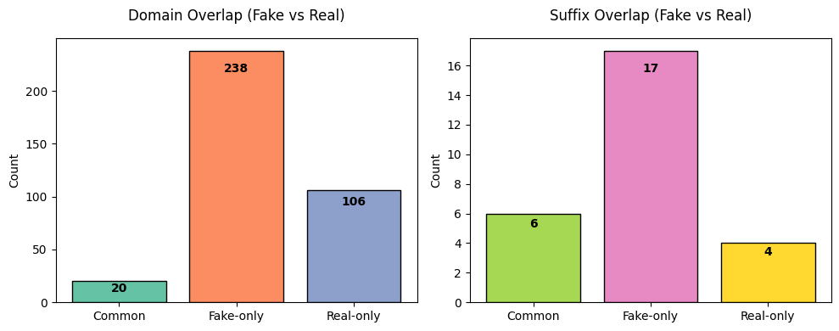
We can further show the fake vs real news domains using a cloud words data visualization. This scales the text/words to their respective frequency within the dataset. This mirrors a 2024 study by Frontiers in Big Data noted similar concerns of “rapid dissemination” as well as fake-to-real data comparisons [2].
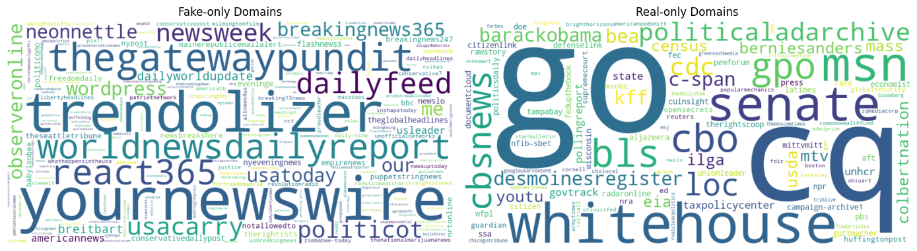
Data Exploration – Processing Titles
Titles are essential in online journalism and communication. For twitter, titles are the gateway to interest. Inflammatory, polarizing titles drive viewership, or at least our normalized mean tweet counts would seem that way. But now we had to measure just how polarizing and inflammatory these titles were. Utilizing Text Blob and VADER we were able to conduct sentiment values on news. A larger portion of real news maintains a 0.0 polarity, indicating less positive or negative news. While the sharp contrast is impressive, VADER showed an even larger contrast. So much so that when conducting a t-test, the p-value for VADER sentiment was 6.75e-27 vs Text Blob’s 0.006. Both were acceptable for rejecting the null hypothesis, but VADER was more sensitive to the fake news sentiment.
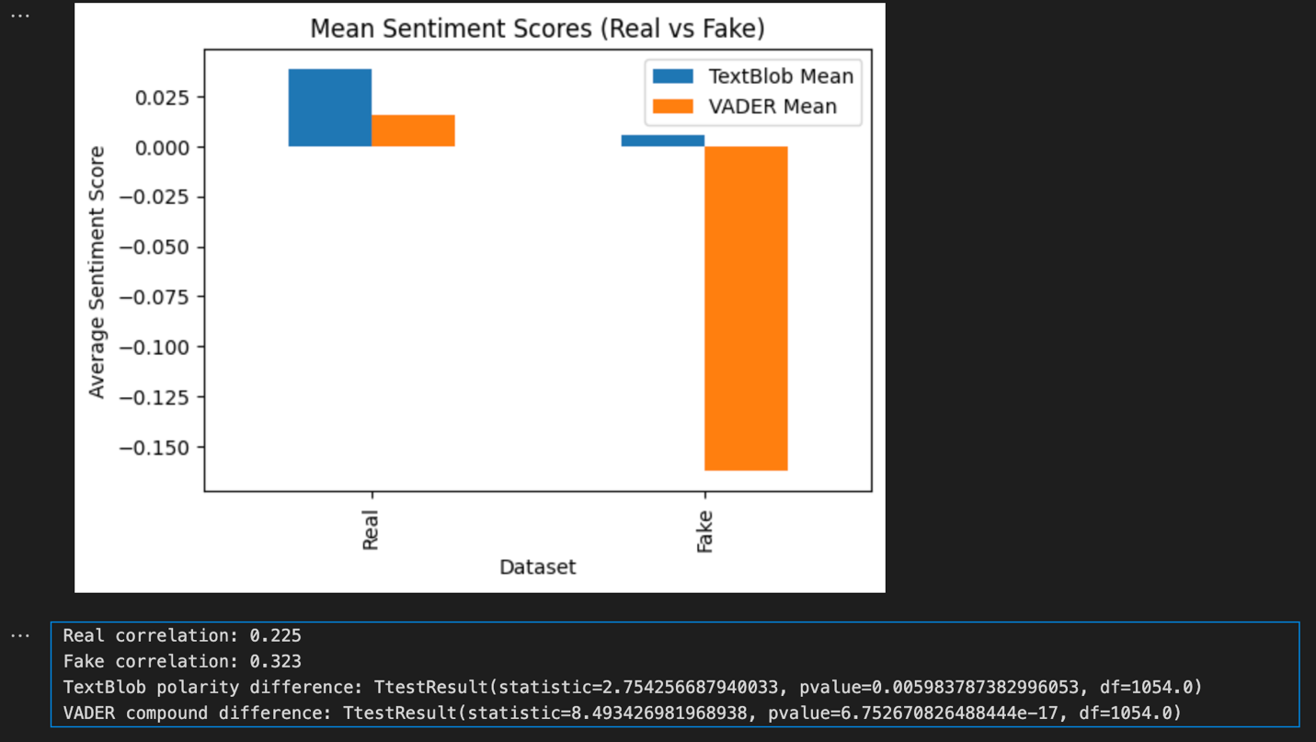
Further emphasizing the use of polarizing language and writing, we introduced two additional features: one for counting the number of uppercase characters and another for the usage of exclamation points. This time, a stark contrast emerges. On average, fake news articles tend to have more capital letters and exclamation marks. For instance, consider our earlier GovDeception tweet titled “BREAKING: First NFL Team Declares Bankruptcy Over Kneeling Thugs”. The title itself is formatted in an unusual manner, with each word capitalized, including a full caps “BREAKING”.
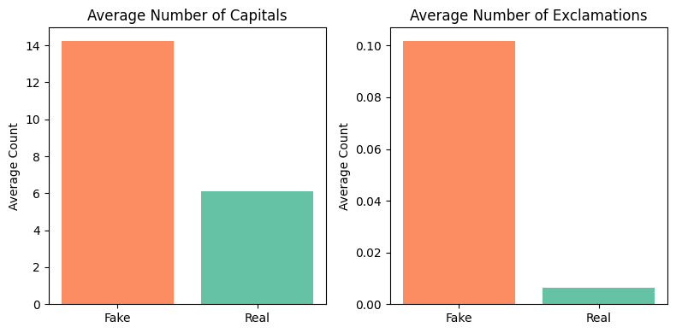
Modeling & Prediction
The cleaned data along with feature engineering gave us the opportunity to train and predict fake news. We ran multiple model types against the training set and captured results for XGBoost, Logistic Regression, and Linear SVC. These types matched the same model types used by Elsa Norman [3] in a similar problem. Each model type surpassed our 75% accuracy goal. The feature importance further illustrates how our engineered features stand out between fake and real classes. As previously mentioned, this data is largely temporal, so I would hesitate in deploying this to a real-time environment, but the core functionality is sound and confirms our hypothesis: fake news can be predicted to a degree of certainty.
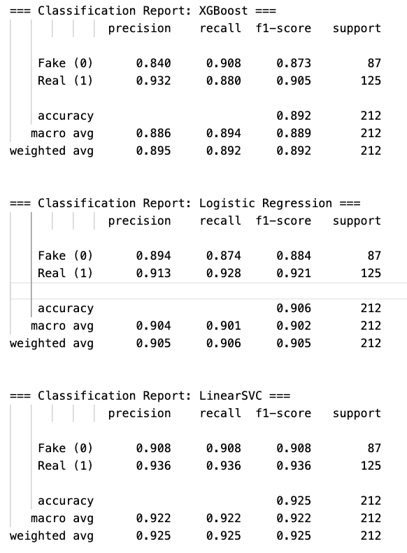

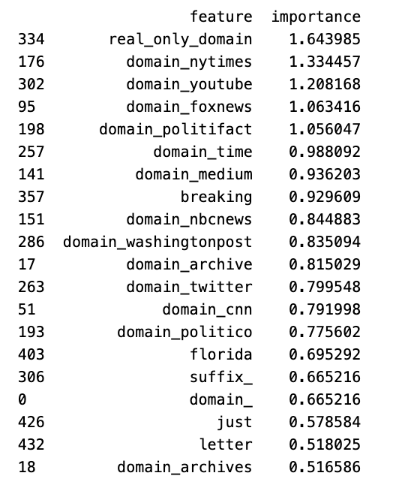

References:
- Golovin, Aleksei. “Fake News.” Www.kaggle.com, 2021, www.kaggle.com/datasets/algord/fake-news.
- Halyna Padalko, et al. “A Novel Approach to Fake News Classification Using LSTM-Based Deep Learning Models.” Frontiers in Big Data, vol. 6, no. 1320800, 8 Jan. 2024, https://doi.org/10.3389/fdata.2023.1320800.
- Norman, Elsa. “Detecting Fake News Using Machine Learning.” Journal of Student Research, vol. 12, no. 1, 28 Feb. 2023, https://doi.org/10.47611/jsrhs.v12i1.3940. Accessed 5 May 2023.

10 Questions I anticipate:
- How can one distinguish between genuine and fabricated news?
  - The best indicator is the language used in the title. Inflammatory all caps language is commonly associated with fake news. Domains/URLs are also indicative of fake news resources.
- Would this intervention hinder the freedom of expression of users?
  - Not at all! This dataset was explicitly trained on the posting of articles. If a user wanted to post a fake news article, their account and post would be flagged, but if they want to share their opinions, that would still be allowed.
- What are the potential risks associated with the dissemination of fabricated news?
  - Fake news can lead to all sorts of societal ills, such as violence, erosion of trust, pitting groups against each other.
- Should the government take action to address this issue?
  - Our models can be trained without government intervention. The possibility of the government weaponizing this technology and targeting opposing viewpoints as “fake news” is worrisome. If social media websites such as Twitter and Facebook are unwilling to implement these changes, it could be regulated.
- What level of accuracy can be anticipated in distinguishing between authentic and fabricated news?
  - We can predict with up to 90% accuracy whether a news article is fake or real.
- Why has this problem not been resolved yet?
  - There is a financial incentive to allow salacious fake news on social media. The content is highly engaging and can be monetized. Social media websites need to be pushed by their users or by governments to crack down on social media if they won’t do some themselves.
- Is the situation improving or deteriorating?
  - Despite advancements in technology, fake news is still quite common. The main problem today is that fake news is not a priority when content is posted. All in all, the situation is deteriorating.
- Is fabricated news specifically targeting a particular demographic group?
  - Fake news can be biased against any groups. It plays into fears and desires of the readers. Based on a large number of fake news originating from countries such as Russia, China, and Iran, foreign influence is attempting to erode the unity within the United States and the West as part of a regional power play.
- Which models were selected and for what reasons?
  - I chose 3 different models, SVC, logistic and gradient boost. Based on the recommendations from Elsa Norman, these models were best suited for the classification test.
- Which dataset was chosen and for what reasons?
  - I chose an open-source dataset from Kaggle. First, it was best suited for the problem as it contained the data along with “fake/real” labels. Second, the dataset I chose had already been downloaded 10,000 times. Think of this as the data being “peer reviewed” 10,000 times. Finally, the dataset was compiled from PolitiFact fact checkers, so each item had already been proven true or false and could be traced back to the PolitiFact website.

